Uthman Ibn Affan was a man so loved by Prophet Muhammad, may the mercy and blessings of God be upon him, that he was called *the possessor of two lights*.  Uthman was married to Prophet Muhammad’s daughter Ruqiayah and when she died, he married Muhammad’s other daughter, Umm Kulthum, thus possessing the two lights.

 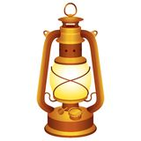

Uthman, may God be pleased with him, was born seven years after Prophet Muhammad, may the mercy and blessings of God be upon him, and belonged to the Umayyad branch of the Quraish tribe.  The Umayyads were the most influential clan of the Quraish, they were the strongest and wealthiest, and Uthman was their “golden child”, the most beloved, due to his good manners and shyness.  Like his predecessor Omar ibn Al Khattab, Uthman was able to read and write.  This was an unusual skill in pre Islamic Arabia and Uthman became a successful trader and cloth merchant.  Throughout his life he was known as a kind, generous man and even before his conversion to Islam he would freely give money to help those in need.

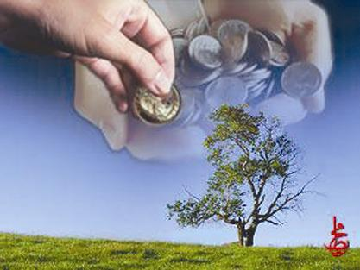

Uthman gave freely from his wealth to please God and His messenger Muhammad.  Historical Islamic stories mention that every Friday Uthman would buy slaves for the purpose of setting them free and that although he was wealthy he was often without servants because of this habit.  When Prophet Muhammad and the Muslim armies were going to fight the Byzantines at Tabuk, he called on the wealthier people to give from their wealth and property to support and equip the soldiers.  Uthman presented 200 saddled camels and 200 ounces of gold.  He also gave 1,000 dinars.  Prophet Muhammad kept asking for donations hoping to inspire others to give as freely as Uthman.  However, it was Uthman who surpassed them all and gave a total of 900 equipped camels.

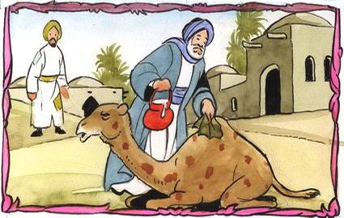 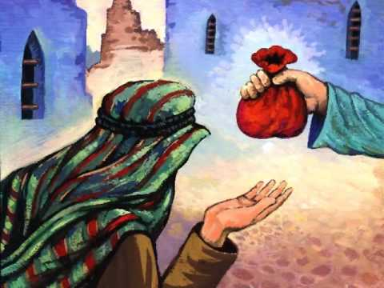

In Medina, water was scarce and control of the wells was tightly held by several men.  Because he was a skilful trader and negotiator, Uthman set about trying to procure a well for the use of the Muslims.  He negotiated a price for half a well; he would have control one day and the other owner the next day.  However, Uthman gave his water to the Muslims freely, so nobody wanted to pay for the water on the alternate days.  The original owner of the well had no choice but to sell his half of the well to Uthman who nevertheless paid a fair price for it.  Uthman continued to allow the water to be used freely by all and never reminded the people of his charity.  He was humble and modest.

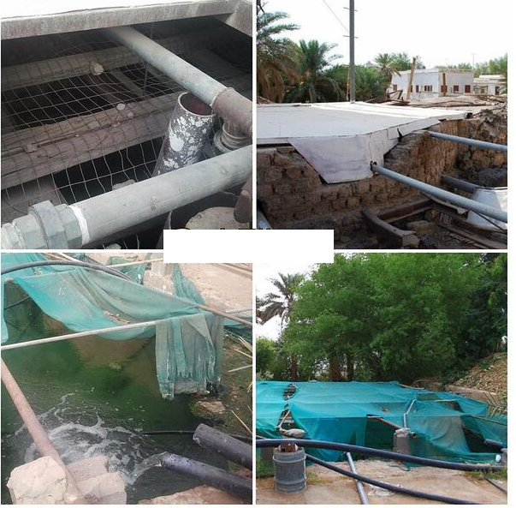

Uthman ibn Affan was the third of Prophet Muhammad’s successors. Umar, on his deathbed formed a committee of six people to choose the next Caliph from amongst themselves. This committee was:

[**Ali**](https://en.wikipedia.org/wiki/Ali)**, Uthman ibn Affan,** [**Abdur Rahman bin Awf**](https://en.wikipedia.org/wiki/Abdur_Rahman_bin_Awf)**,** [**Sa`d ibn Abi Waqqas**](https://en.wikipedia.org/wiki/Sa%60d_ibn_Abi_Waqqas)**,** [**Al-Zubayr**](https://en.wikipedia.org/wiki/Al-Zubayr)**, and** [**Talhah**](https://en.wikipedia.org/wiki/Talhah)**.**

Umar asked that, after his death, the committee reach a final decision within three days, and the next Caliph should take the oath of office on the fourth day. If Talhah joined the committee within this period, he was to take part in the deliberations, but if he did not return to Medina within this period, the other members of the committee could proceed with the decision. Abdur Rahman bin Awf withdrew his eligibility to be appointed as Caliph in order to act as a moderator and began his task by interviewing every member of the committee separately. He asked them for whom they would cast their vote. When Ali was asked, he didn't reply. When Uthman was asked, he voted for Ali, Zubayr said for Ali or Uthman. and Saad said for Uthman.

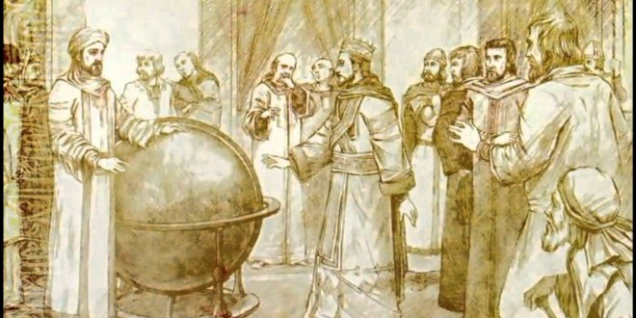

Uthman was known as the leader of the faithful and ruled for approximately 12 years.  The first six years were times of relative tranquility and peace, however the last years of his reign were marred by internal conflict, and pockets of rebels trying to cause havoc throughout the Caliphate. Uthman is remembered as a pious, gentle, and kind man, known for his modesty and shyness, and admired for his generosity.  He ruled with impartial justice and mild and humane policies, based on his obedience to God and his love for Prophet Muhammad and the Muslim nation.

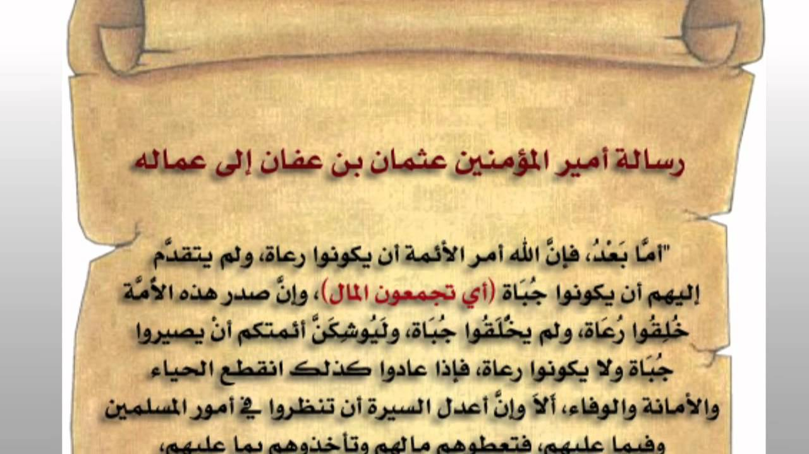

The Holy Quran was revealed to the Holy Prophet in parts extending over a period of twenty-three years. The Quran had been gathered during the time of Abu Bakr and was in the safekeeping of Prophet Muhammad’s wife Hafsah.

After the death of Prophet Muhammad (PBUH), and during the time of the Caliphs, hundreds of thousands of non-Arabs converted to Islam.

One of Prophet Mohammad’s companions, and Uthman’s friend Hudhaifah, who had been to different parts of the Muslim Empire reported that the people of different regions had different readings of the Holy Quran.  Hudhaifah suggested to Uthman that there will be an official version written in the style used in Medina. Uthman (may Allah be pleased with him) knew the Quran by heart and had intimate knowledge of the context and circumstances relating to each verse. He appointed a Committee. They took possession of the originals and ordered some of the trusted companions to make careful copies.  Uthman checked the compilation himself and finally approved it. He then ordered all other unofficial copies to be burned or otherwise destroyed.  Five official copies were sent to the greatest cities of the Muslim Caliphate. The Committee worked hard and Uthman deserves the gratitude of the Muslims by this single service in preserving the Holy Quran in its original form free from any corruption.

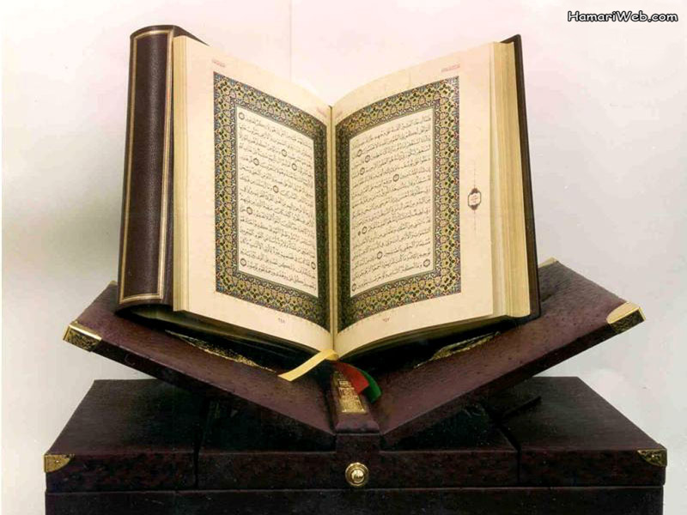

Uthman Ibn Affan was born in Taif, near Mecca in 576 A.D, approximately six years after the Year of the Elephant.

He was born from an hounourable rich family named Banu Umayyah. After the death of his father Affan Ibn Abi Al-Aas who was a wealthy merchant, Uthman bore the responsibility of the family business at an early age; he worked hard to enrich his business that his good reputation as a hard-worker was easily spread among people.

He was said to be a very truthful and bashful person who also possessed a powerful personality. A modest, honest, mild, generous and very kindly man, Uthman was also noted for his piety.

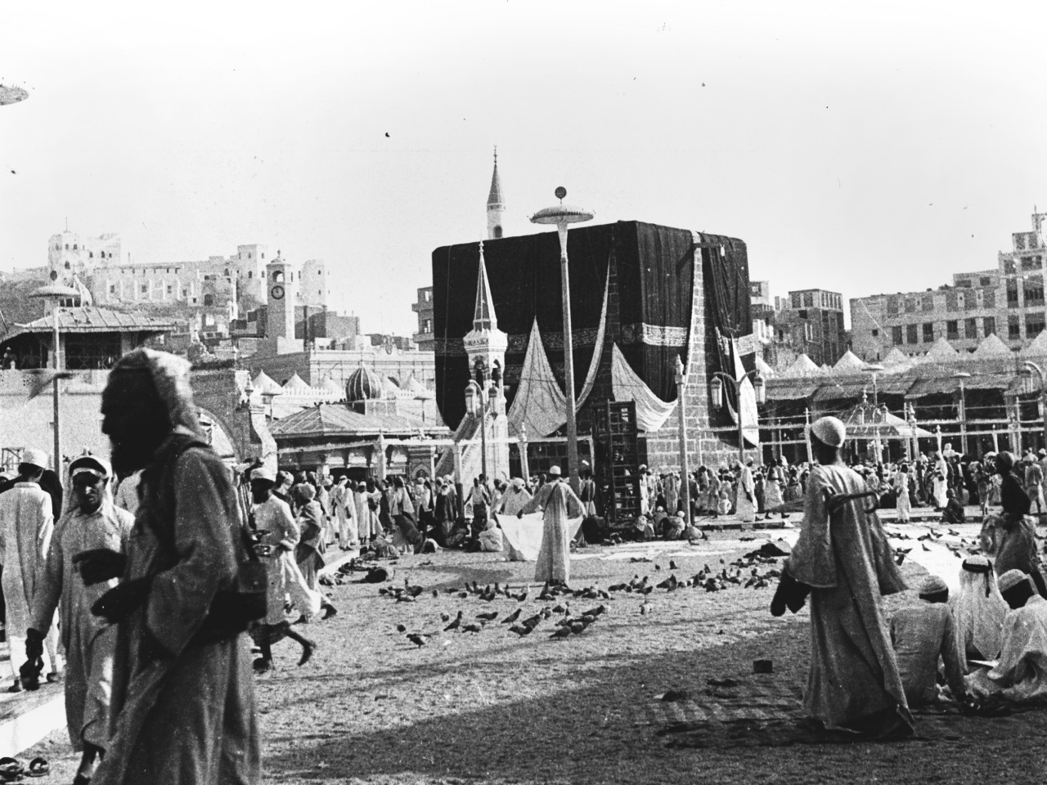

By virtue of his travels, primarily to either Yemen or Syria, Uthman had gained exposure to various people and their beliefs, developing the knowledge of their customs and culture. One day, Uthman had a dream about Islam while coming back from his journey from Syria. He then learnt of the new religion and the Prophet PBUH.

His aunt Su’da bint Kuraz informed him one day about the coming of the Prophet Muhammad. Uthman was 34 years old when he made his way to Abu Bakr whom he knew to be a close friend of Prophet Muhammad PBUH and who had already converted to Islam. He asked him to accompany him to meet the Prophet PBUH in order to embrace Islam.

It is said that he was one of the early converts to have accepted Islam through the efforts of Abu Bakr asseddiq.

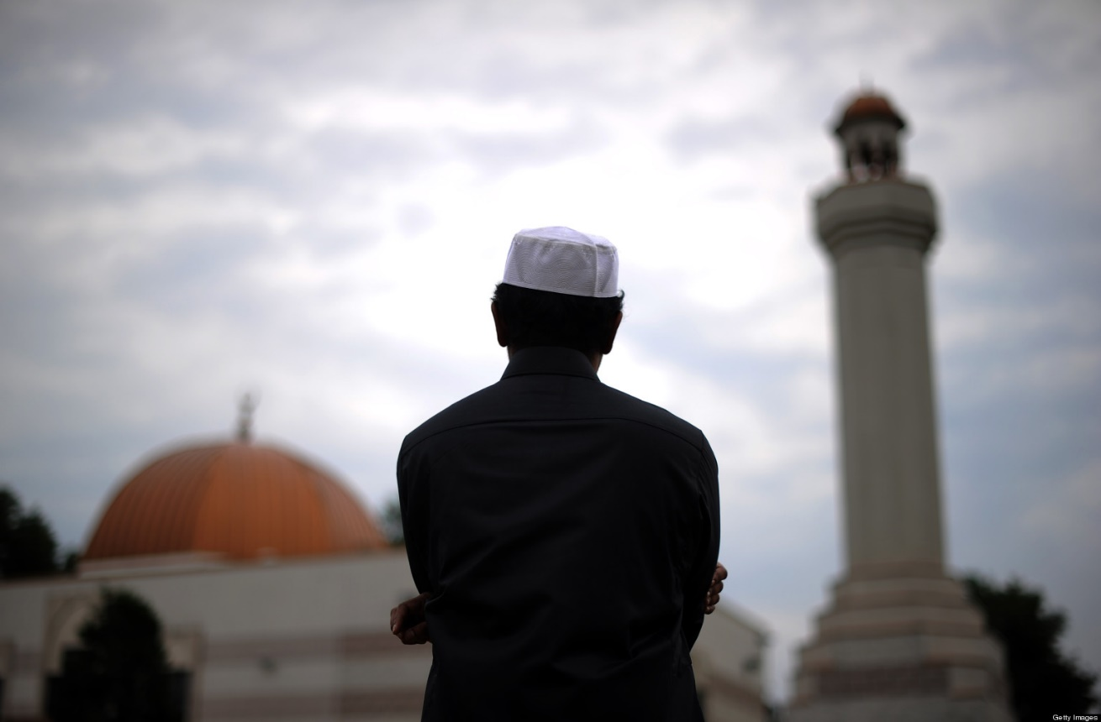

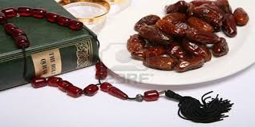

Uthman Ibn Affan (may Allah be pleased with him) served Islam with devotion. He has been known to spend nights in prayer, observed fasts most of the days, sometimes on alternative days and performed hajj every year.

He knew the Holy Quran by heart, and would complete the recitation of the Holy Quran during a night.

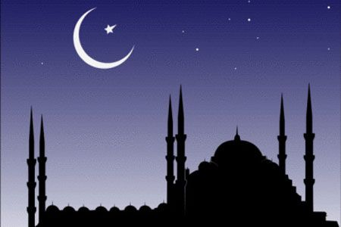

Uthman Ibn Affan spent all his life to serve Islam. When he was a khalifa, Uthman sent reminders to his governors about their role in the society that is to promote Islam and its values, assist Muslims and protect the non-believers.

In the time of the Holy Prophet, Abu Bakr, and Umar, no Zakat was put on horses and slaves. Uthman reviewed it and ordered to give Zakat on horses and slaves.

On the occasion of the Ramadhan, Uthman increased the daily allowances of the people. He also arranged to supply free meals to all concerned at the time of the breaking of the fast.

The Islamic State had expanded in every direction, from Egypt and Syria to north Africa, Europe, Iran, Iraq and Asia. He followed the commands of Islam rigorously in letter as well as in spirit.

